Test Case: tc003_SPX_Dev5_Crear_Requisicion_Spot_Tipo_Cobro_CC_Urgent
Step 1 - Enter username and password and click to button Enter : Credentials Entered
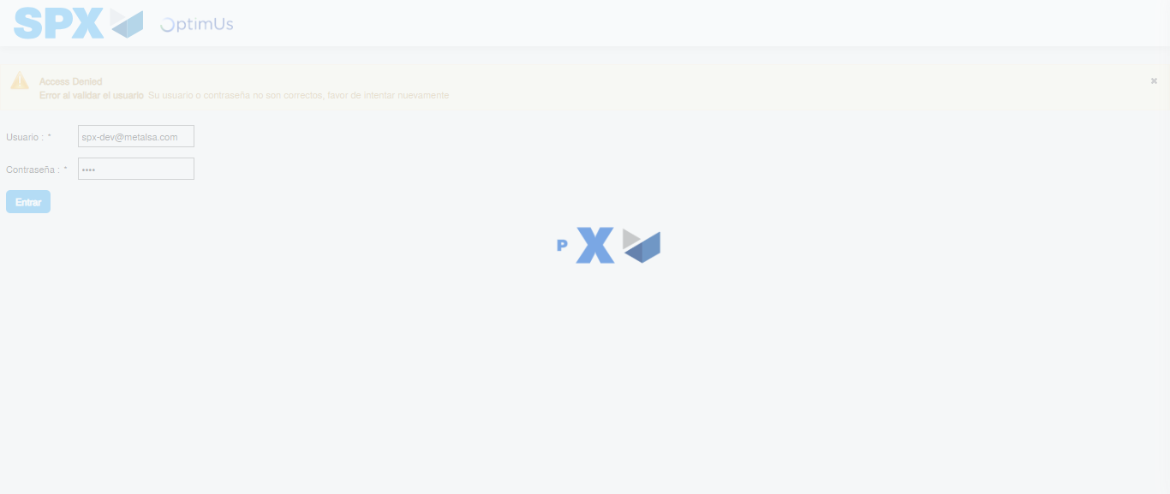Image file-name: QC_Testing-tc003_SPX_Dev5_Crear_Requisicion_Spot_Tipo_Cobro_CC_Urgent-1783356809901

Step 2 - Select to UEN and Access to Spot Buy Requisitions : UEN Correctly selected and Correct access
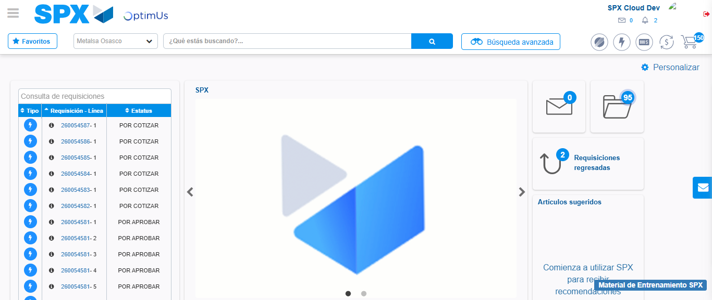Image file-name: QC_Testing-tc003_SPX_Dev5_Crear_Requisicion_Spot_Tipo_Cobro_CC_Urgent-1783356835904

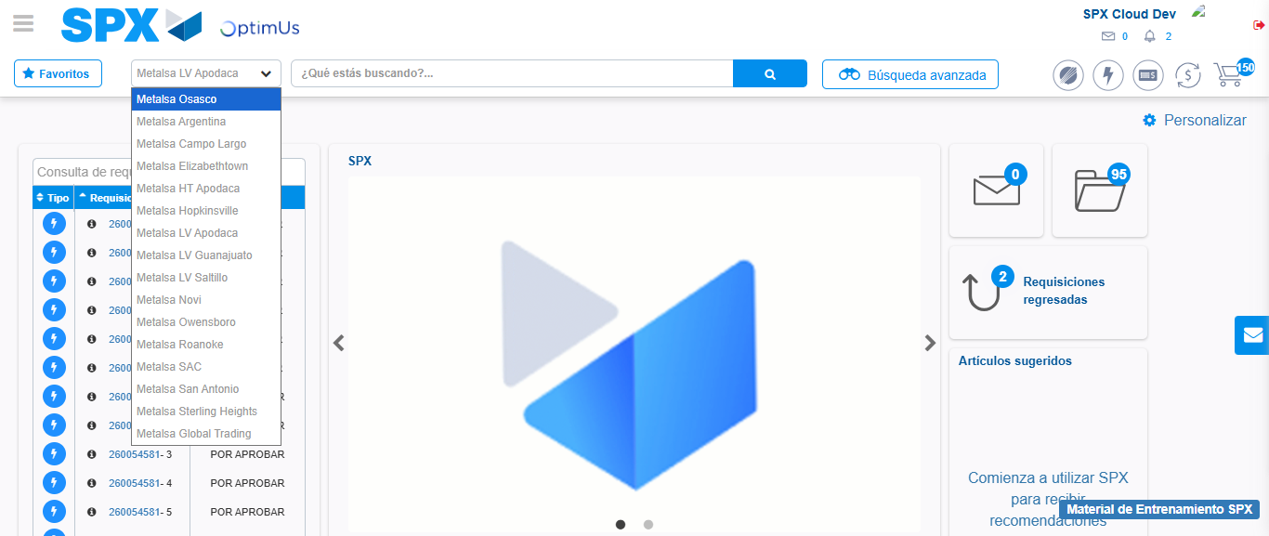Image file-name: QC_Testing-tc003_SPX_Dev5_Crear_Requisicion_Spot_Tipo_Cobro_CC_Urgent-1783356838668

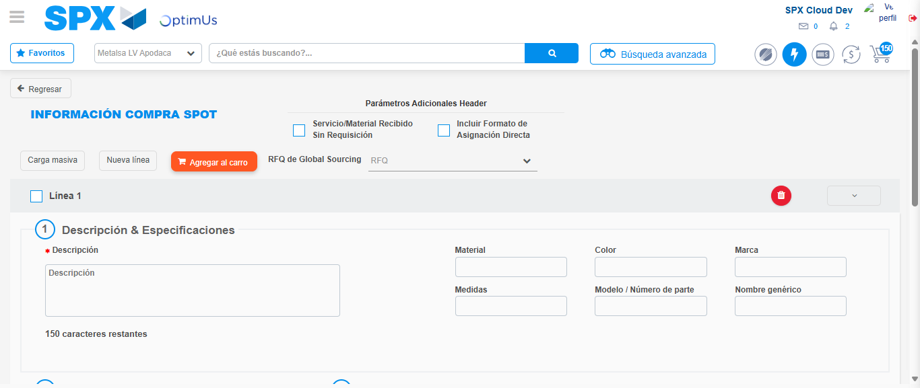Image file-name: QC_Testing-tc003_SPX_Dev5_Crear_Requisicion_Spot_Tipo_Cobro_CC_Urgent-1783356859616

Step 3 - Data Capture Spot Buy Requisition: Data captured correctly
Image file-name: QC_Testing-tc003_SPX_Dev5_Crear_Requisicion_Spot_Tipo_Cobro_CC_Urgent-1783356860019

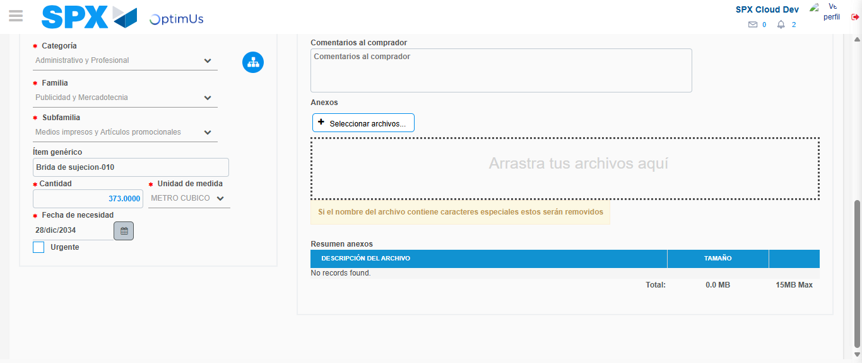Image file-name: QC_Testing-tc003_SPX_Dev5_Crear_Requisicion_Spot_Tipo_Cobro_CC_Urgent-1783356872763

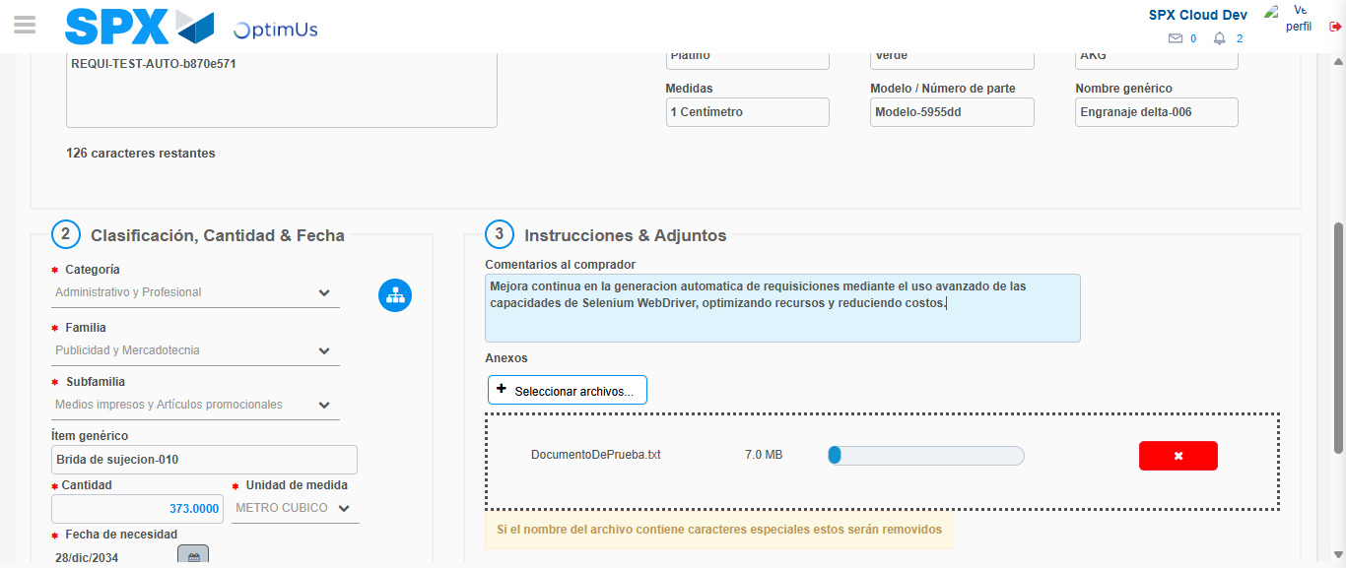Image file-name: QC_Testing-tc003_SPX_Dev5_Crear_Requisicion_Spot_Tipo_Cobro_CC_Urgent-1783356873745

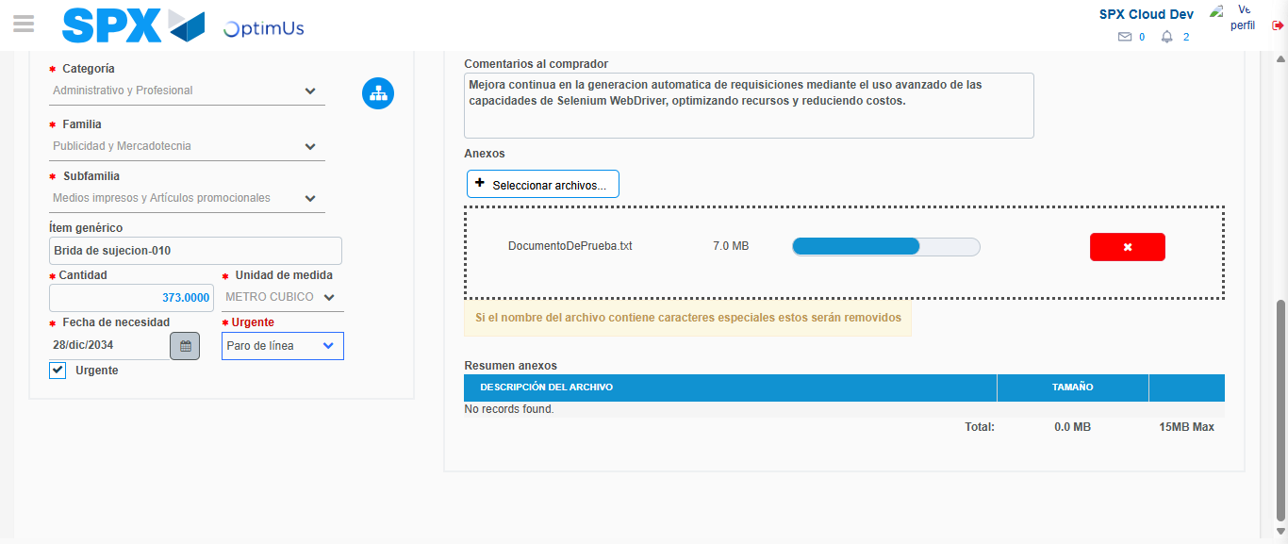Image file-name: QC_Testing-tc003_SPX_Dev5_Crear_Requisicion_Spot_Tipo_Cobro_CC_Urgent-1783356878211

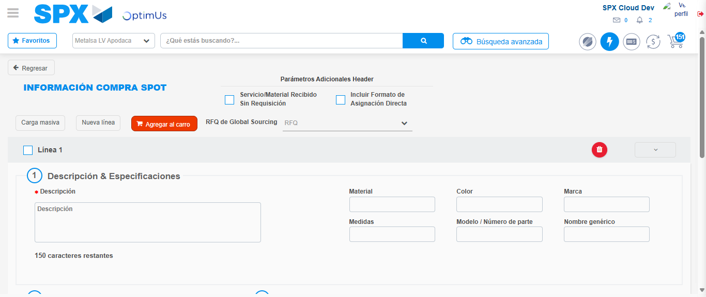Image file-name: QC_Testing-tc003_SPX_Dev5_Crear_Requisicion_Spot_Tipo_Cobro_CC_Urgent-1783356888105

Step 7 - Return to Main Page SPX : Return to Main Page SPX
Image file-name: QC_Testing-tc003_SPX_Dev5_Crear_Requisicion_Spot_Tipo_Cobro_CC_Urgent-1783356835904

Image file-name: QC_Testing-tc003_SPX_Dev5_Crear_Requisicion_Spot_Tipo_Cobro_CC_Urgent-1783356838668

Image file-name: QC_Testing-tc003_SPX_Dev5_Crear_Requisicion_Spot_Tipo_Cobro_CC_Urgent-1783356859616

Image file-name: QC_Testing-tc003_SPX_Dev5_Crear_Requisicion_Spot_Tipo_Cobro_CC_Urgent-1783356890385

Image file-name: QC_Testing-tc003_SPX_Dev5_Crear_Requisicion_Spot_Tipo_Cobro_CC_Urgent-1783356890581

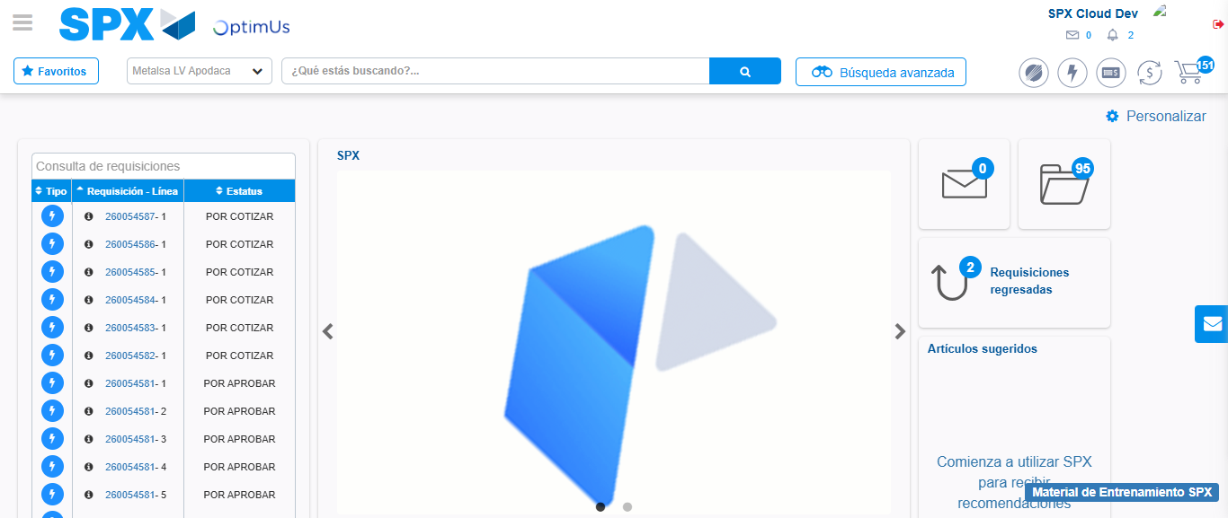Image file-name: QC_Testing-tc003_SPX_Dev5_Crear_Requisicion_Spot_Tipo_Cobro_CC_Urgent-1783356911874

Step 8 - Log Out : Log Out SPX
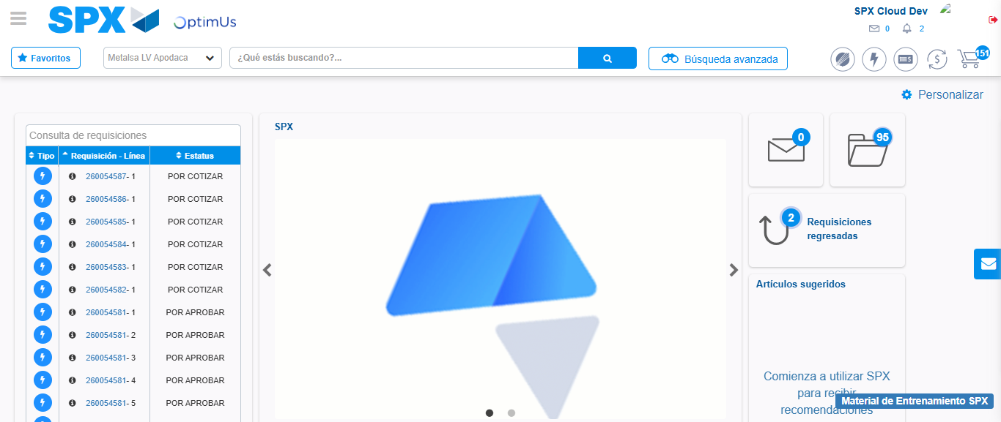Image file-name: QC_Testing-tc003_SPX_Dev5_Crear_Requisicion_Spot_Tipo_Cobro_CC_Urgent-1783356912283

